**What is the total number of crimes by month?**

Initial assumption states that winter season has higher crime rate as compared to the summer season. By looking at the dataset I needed to figure out how to generate results from it. The data did not include the parameters that were required. Had to create a new column with named months from the reported date.

Used that to generate the plot shown below to see if winter does have a higher crime rate.

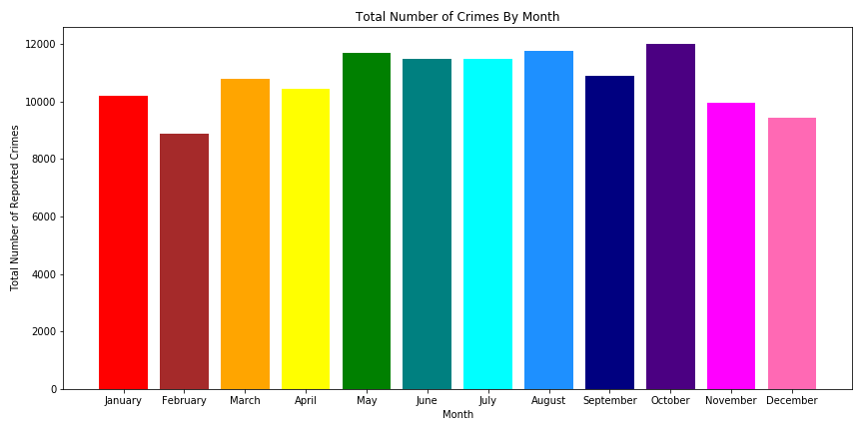

The graph shows a fluctuation in the total’s over the months. But still does help us determine if winter has a higher crime rate. Had to simplify the data more by grouping months into summer – warmer months (Apr, May, Jun, Jul, Aug, Sep), and winter – cooler months (Oct, Nov, Dec, Jan, Feb, Mar). But the following findings negated our assumption that winter does not have a higher crime rate.

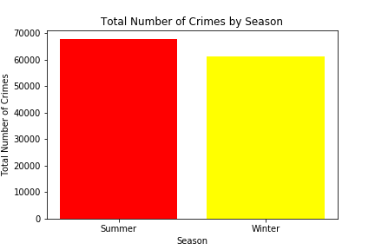

Summer has a higher rate in total for the crimes as to winter, but the difference is small about 500 in total, then rose the question if this small difference does hold any significance or not. So, I ran the chi-square analysis, with a critical value of 5.99 and a statistical value of 326.3, and p-value 6.25 *10^-73. With p-value < 0.05, it does hold true that this small difference does matter a lot.

Then ran the chi-square test by quarter and month to see if the change in month matters as well or not, and the findings show that the p-value < 0.05 for both.

**What is the total of different categories of crimes by month?**

Next, we wanted to look at the total of each crime month. Took a lot of time to sort out the data because it had a total of 122 crime types, with the same crime described in different ways. Condensed the types to about 66 in total. Still it was hard to present so many types on one visual, so had to break down those types into categories; personal, property, statutory, financial, and other.

Among these categories’ property crimes has the highest total.

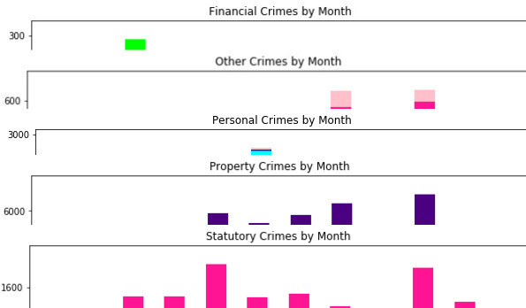

Property Crime is defined by the following type of crime:

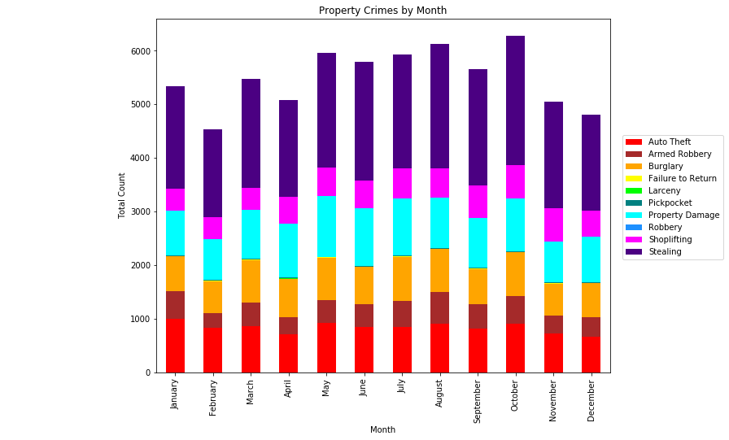

In the above plot we can see that auto theft, property damage, and stealing are the most common crimes committed. Stealing is the top most committed crime, which holds our assumption true. But it is hard to determine by looking at the visual above that it was in higher in winter or not. So, to determine if stealing rate was higher in winter summer, the total for stealing had to broken down further by season.

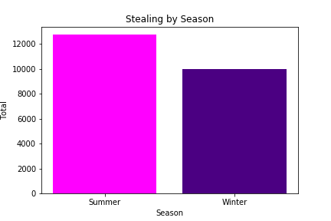

The above figure further negates the assumption that crime rate for stealing was higher in winter. Further statistical analysis still has to be run in order to run if this difference does hold any significance but, because it is irrelevant to the assumption which was just to determine if the ‘stealing(larceny/theft) by young males during the “Winter” months’ holds true.